

DESIGN AND IMPLEMENTATION OF A SECURE NETWORK-BASED FILE TRANSFER AND SHARING SYSTEM

A CAPSTONE PROJECT REPORT

A Capstone Project Report submitted in partial fulfilment of the requirements for the Course of

CSA0702-Computer Networks

to the award of the degree of

BACHELOR OF TECHNOLOGY

IN

COMPUTER SCIENCE AND ENGINEERING
Submitted by
V. Sree Ruthin Reddy (192324112)
Under the Supervision of Guide
Dr. R. Senthamil Selvan
SIMATS ENGINEERING
Saveetha Institute of Medical and Technical Sciences Chennai-602105
SEPTEMBER 2026

SIMATS ENGINEERING
Saveetha Institute of Medical and Technical Sciences Chennai-602105

BONAFIDE CERTIFICATE

This is to certify that the Capstone Project entitled “Design and implementation of a secure network-based file transfer and sharing system” has been carried out by V.Sree Ruthin Reddy (192324112) under the supervision of Dr .R. Senthamil Selvan and is submitted in partial fulfilment of the requirements for the current semester of the B.E CSE-AI&DS at Saveetha Institute of Medical and Technical Sciences, Chennai.

COURSE COORDINATOR COURSE FACULTY
Dr.S.Sivagami Dr. R .Senthamil Selvan
Program Director B.E,MTech,Phd,MISTE,FIETE
Professor Associate Professor
Department of Data Vista / CSE Department of CSE
SIMATS Engineering, SIMATS Engineering,
SIMATS, Chennai – 602105. SIMATS, Chennai – 602105.

SIMATS ENGINEERING
Saveetha Institute of Medical and Technical Sciences Chennai-602105

DECLARATION

I, V.Sree Ruthin Reddy (192324112) of the CSE-AI , SIMATS Engineering, Saveetha Institute of Medical and Technical Sciences, Chennai, hereby declare that the Capstone Project Work entitled “Design and implementation of a secure network-based file transfer and sharing system” is the result of our own bonafide efforts. To the best of our knowledge, the work presented herein is original and has been carried out in accordance with engineering ethics and academic integrity. All sources, software libraries, development tools and AI-assisted resources used during the project have been appropriately acknowledged. The data, results and analysis presented in this report have not been knowingly fabricated or manipulated.

Place: Chennai
Date: September 2026

Signature of the Students with Names
V.Sree Ruthin Reddy

SIMATS ENGINEERING
Saveetha Institute of Medical and Technical Sciences Chennai-602105

Individual Contribution Statement

Student Name / Register No. | Specific  Responsibilities | Design & Development Contribution | Testing & Analysis  Contribution | Report Contribution | Approx.  Contribution (%)
V.Sree Ruthin Reddy | Maze generation, gameplay integration | Core maze and gameplay modules | Functional and integration testing | Chapters 1, 3 and 4 | 50%
V.Sheershika | AI navigation and path analysis | A*, BFS, AI and analysis modules | Algorithm and AI testing | Chapters 2, 4 and 5 | 50%
Total |  |  |  |  | 100%

ABSTRACT
The Secure Network-Based File Transfer and Sharing System is a client-server application developed to combine secure network communication, file transfer, encryption, authentication, access control and activity monitoring within a single system. Conventional file-sharing systems may focus mainly on transferring files and provide limited protection against unauthorized access, insecure password storage and uncontrolled file sharing. The proposed system addresses these limitations by providing authenticated user access, encrypted file handling and controlled sharing between authorized users.
The system is implemented in Java using TCP/IP socket programming for communication between clients and the server. A client-server architecture is used to manage user requests and file operations centrally. User passwords are protected using BCrypt hashing, while AES encryption is used to secure sensitive file data during storage and transmission. JDBC and MySQL are used to manage user information, file-related data and system records. Role-Based Access Control (RBAC) and Access Control Lists (ACL) are incorporated to control user permissions and restrict unauthorized access to files.
The system supports secure user authentication, file upload, file download and controlled file sharing. Before performing file operations, the system verifies user authorization and access permissions. Important activities such as login attempts and file operations are recorded through audit logging, providing accountability and supporting system monitoring. Functional testing covers authentication, client-server communication, file transfer, encryption, access control, authorized and unauthorized access, and audit logging.
The completed prototype demonstrates that TCP/IP networking, socket programming, encryption, password security, database connectivity and access-control mechanisms can be integrated into one practical secure file-sharing application. The project provides a practical implementation of Computer Networks concepts while offering improved confidentiality, controlled accessibility and accountability for network-based file transfer.
Keywords
Secure File Transfer, TCP/IP, Socket Programming, Client-Server Architecture, AES Encryption, BCrypt, RBAC, ACL, JDBC, MySQL, Audit Logging

TABLE OF CONTENTS

i | CERTIFICATE FROM THE SUPERVISOR | ii
ii | DECLARATION BY THE CANDIDATE | iii
iii | INDIVIDUAL CONTRIBUTION STATEMENT | iv
iv | ABSTRACT | v
v | LIST OF FIGURES | vi
vi | LIST OF TABLES | vii
vii | LIST OF ABBREVIATIONS | viii
1 | CHAPTER 1: Introduction | 7
2 | CHAPTER 2: Literature Review | 8
3 | CHAPTER 3: Engineering Design & Trade-offs, Sustainability, Ethics, Safety, Risk & Security | 10
4 | CHAPTER 4: Implementation, Testing & Results, Project Management | 14
5 | CHAPTER 5: Conclusion & Reflection | 17
 | References
 | Appendices
 | Appendices

LIST OF FIGURES

Figure No. | Figure Name | Page No.
1 | System Workflow of the Project | 8
2 | Login Page of the Project | 9
3 | Register page of the project | 10
4 | Uploaded files listed in the image | 13
5 | Shared files displayed | 14
6 | Dashboard of the project | 15

LIST OF TABLES

Table  No. | Table Name | Page  No.
1 | Stakeholder and functional requirements | 10
2 | Design specifications | 11
3 | Alternative solution evaluation | 14
4 | Trade-off analysis | 15
5 | Risk register | 16

LIST OF ABBREVIATIONS / SYMBOLS

Symbol | Description | Unit
AI | Artificial Intelligence | –
A* | A-Star Search Algorithm | –
BFS | Breadth-First Search | –

CHAPTER 1
INTRODUCTION AND ENGINEERING PROBLEM
  - Background
Secure file transfer and sharing is an important requirement in computer networks because sensitive information is frequently exchanged between users over network connections. The proposed system combines client-server communication, user authentication, file encryption, secure storage, access control and activity monitoring within a single application. TCP/IP socket communication is used to support file exchange, while security mechanisms ensure that files and user information are protected throughout the process.
  - Need for the Project
The project is required to provide a secure and controlled method for transferring and sharing files over a network.
  - Problem Statement
The engineering problem is to develop a reliable network-based file transfer and sharing system that enables secure communication between clients and a server, protects user credentials, encrypts sensitive files and restricts unauthorized access. The system must maintain secure authentication, controlled file sharing, access permissions and activity monitoring while operating within the constraints of a client-server network environment.
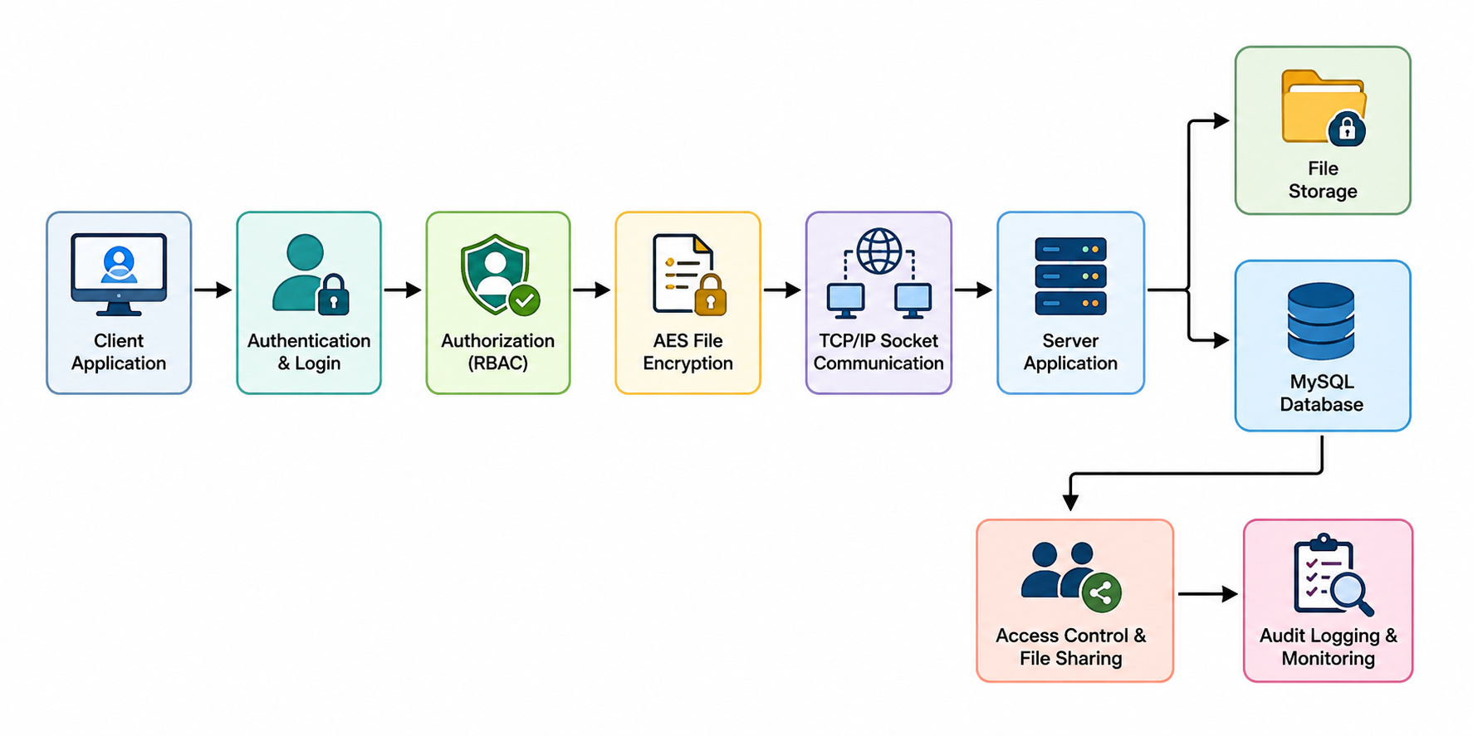
Fig.1.1 System Workflow of the Project
  - Project Aim
The aim is to design and develop a secure network-based file transfer and sharing system that integrates TCP/IP communication, authentication, encryption and access-control mechanisms for secure file exchange and controlled resource sharing.
  - Project Objectives
The project objectives are:
- To design a client-server architecture for secure network-based file transfer.
- To establish communication between clients and the server using TCP/IP socket programming.
- To implement secure user authentication and authorization using BCrypt password hashing.
- To implement AES encryption for protecting sensitive file data during storage and transmission.
- To provide controlled file access and sharing using RBAC and Access Control Lists.
- To integrate MySQL and JDBC for managing user, file and system-related information.
- To implement audit logging and monitoring of important user and file operations.

  - Expected Engineering Outcome

The intended engineering outcome is a functional secure network-based software prototype integrating communication, security mechanisms, access control and file-sharing operations.
● System: integrated secure file transfer and sharing application.
● Product: functional client-server software prototype.
● Process: authenticate → authorize → encrypt → transfer → store → monitor.
● Prototype: secure multi-user file transfer and sharing environment.
● Communication: TCP/IP-based client-server communication using socket programming.
● Security: BCrypt password hashing and AES file encryption.
● Model: Role-Based Access Control (RBAC) and Access Control List (ACL) permission model.
● Device: desktop computer-based client and server environment.
● Infrastructure solution: local network/client-server software execution environment.

Fig.1.1Login Page Fig.1.2 Login Page
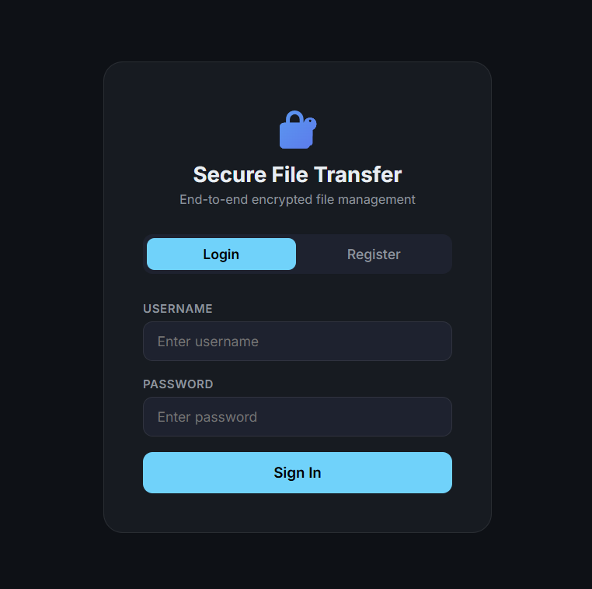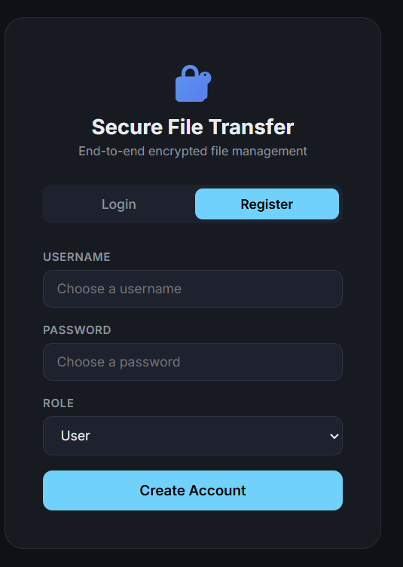

CHAPTER 2
LITERATURE REVIEW AND EXISTING SOLUTIONS
  - Review Method
Relevant literature was reviewed by focusing on secure file transfer systems, client-server architectures, TCP/IP communication, encryption techniques, user authentication and access-control mechanisms. Research papers and technical documentation were compared based on security, reliability, implementation complexity and applicability to an integrated secure network-based file transfer and sharing prototype.
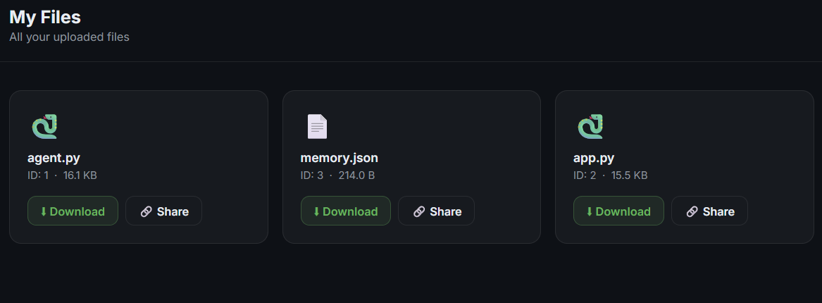
Fig.2.1 Uploaded files
  - Review of Existing Work
Existing research and technologies relevant to the proposed system were reviewed.
● Research papers: studies on secure file transfer, encryption, authentication and access-control mechanisms demonstrate different approaches to protecting data and controlling user access.
● Existing systems: conventional file-sharing systems provide basic upload, download and communication functionality but may offer limited integrated security and access monitoring.
● Commercial solutions: cloud-based file-sharing platforms provide advanced storage and collaboration features but may depend on external infrastructure and are not designed specifically to demonstrate the networking and security mechanisms required by this project.
● Technologies: Java, TCP/IP socket programming, JDBC and MySQL provide a suitable platform for developing a client-server-based file transfer system.
● Methods: AES provides encryption for protecting file data, while BCrypt, RBAC and ACL mechanisms support secure authentication and controlled access.
● Patents: no patent was identified as directly necessary for the core prototype; the work uses established networking, encryption and software security techniques.

  - Comparative Analysis

Existing Approach | Advantages | Limitations | Relevance to Proposed Work
Traditional file transfer systems | Simple file upload and download | Limited integrated security and access control | Provides the basic file transfer concept
TCP/IP socket communication | Reliable client-server communication | Requires separate security mechanisms | Used for network communication and file transfer
AES encryption | Provides strong protection for file data | Requires secure key management | Used to protect sensitive files
BCrypt password hashing | Secure protection of user passwords | Adds authentication processing overhead | Used for secure user authentication
RBAC and ACL | Provides controlled access to users and files | Permission management can become complex | Used for authorization and controlled file sharing
Existing cloud file-sharing systems | Convenient storage and sharing features | Depend on external infrastructure and services | Provides reference for secure file-sharing functionality

  - Research / Engineering Gap
Existing approaches often treat file transfer, user authentication, encryption, access control and activity monitoring as separate functions. The unresolved engineering issue addressed here is their integration into one secure client-server environment where files can be transferred and shared while user access, data protection and system activities are controlled and monitored together.
  - Proposed Contribution
The proposed system integrates secure client-server communication, user authentication, BCrypt password hashing, AES encryption, secure file storage, TCP/IP-based file transfer, RBAC and ACL access control, controlled file sharing and audit logging within a single secure network-based software prototype.

Fig.3.1 File Sharing Page

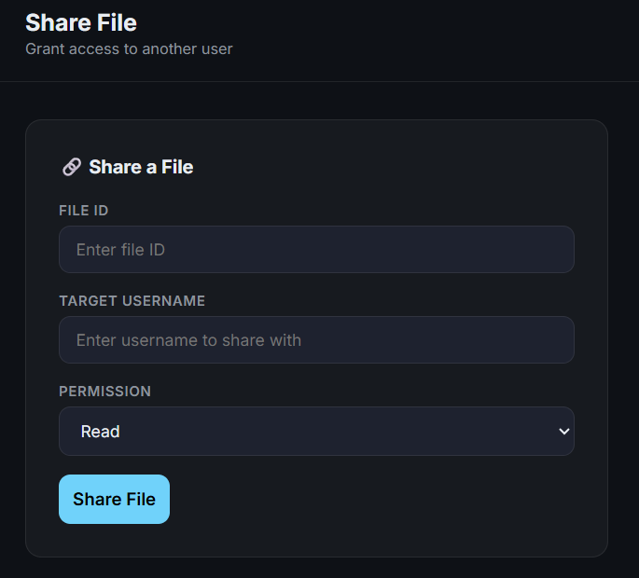

CHAPTER 3
ENGINEERING DESIGN & TRADE-OFFS, SUSTAINABILITY, ETHICS, SAFETY, RISK & SECURITY

  - Requirements
Stakeholder / User Requirements

Stakeholder | Requirement
User | Secure login, reliable file upload/download and controlled file sharing
Student/Learner | Practical demonstration of Computer Networks, socket programming and network security concepts
Administrator | User management, access control and monitoring of important system activities
Developer | Modular and maintainable Java client-server implementation
Functional & Non-Functional Requirements

Requirement | Type (Functional/Non-Functional) | Measurable Target
User authentication | Functional | Only valid users can successfully access the system
File upload | Functional | Authorized users can upload files to the server
File download | Functional | Authorized users can retrieve permitted files
TCP/IP communication | Functional | Successful communication between client and server
AES encryption | Functional | Sensitive file data is protected during handling and storage
Access control | Functional | Unauthorized users are denied restricted file access
File sharing | Functional | Files are shared only according to assigned permissions
Audit logging | Functional | Important login and file operations are recorded

  - Constraints & Applicable Standards

Standard / Code Requirement How Applied in This Project | Standard / Code Requirement How Applied in This Project | Standard / Code Requirement How Applied in This Project
ISO/IEC 25010 Software quality Used for reliability and maintainability | ISO/IEC 25010 Software quality Used for reliability and maintainability | ISO/IEC 25010 Software quality Used for reliability and maintainability

  - Design Specifications

Parameter | Target/Requirement | Unit | Priority
User authentication | Secure user login | Users | High
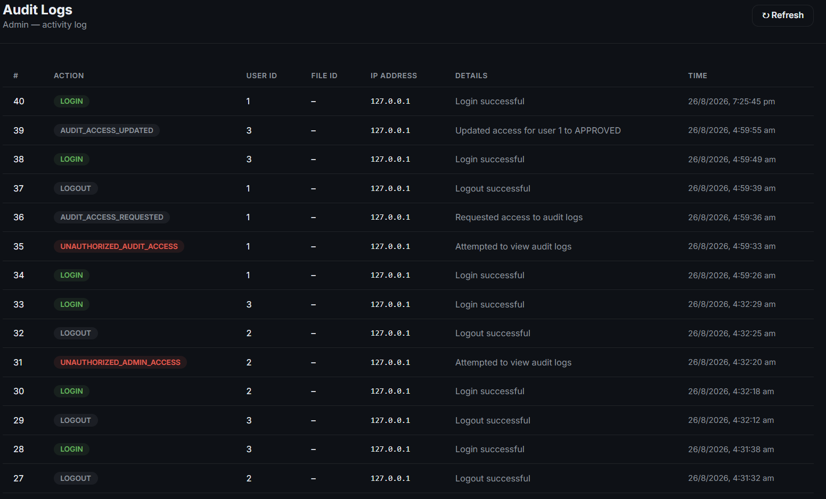
Fig.5.1 Dashboard of the Project
  - Alternative Solutions & Evaluation
Alternative 1: A basic file transfer system provides simple file upload and download but offers limited security.
Alternative 2: A secure client-server system integrates authentication, encryption and access control.
Alternative 3: A cloud-based file-sharing system provides scalability but requires external infrastructure and services.
Criterion | Weight | Alternative 1 | Alternative 2 | Alternative 3
Performance | 30% | 8/10 | 9/10 | 8/10
Cost | 20% | 9/10 | 8/10 | 6/10
Security | 10% | 5/10 | 9/10 | 9/10
Sustainability | 15% | 9/10 | 9/10 | 8/10
Reliability | 25% | 7/10 | 9/10 | 8/10

  - Selected Design & Detailed Design
The secure client-server design was selected because it provides centralized control over user authentication, file storage, encryption and access permissions. It also allows secure communication and controlled file sharing within a single system.
System flow:
Authenticate user → Authorize access → Select file operation → Encrypt/Process file → Transfer file → Store/Share file → Record activity.
The server manages client requests and coordinates the major modules. The authentication module verifies users, while the access-control module checks permissions. The file-transfer module handles communication between clients and the server, and the audit module records important activities. This modular design reduces dependency between security, networking and file-management functions.
  - Trade-off Analysis

Design Decision Alternative Considered Benefit Disadvantage Final Decision & Justification | Design Decision Alternative Considered Benefit Disadvantage Final Decision & Justification | Design Decision Alternative Considered Benefit Disadvantage Final Decision & Justification | Design Decision Alternative Considered Benefit Disadvantage Final Decision & Justification | Design Decision Alternative Considered Benefit Disadvantage Final Decision & Justification
Communication method Basic file transfer TCP/IP provides reliable client-server communication Requires server configuration TCP/IP selected for reliable network communication | Communication method Basic file transfer TCP/IP provides reliable client-server communication Requires server configuration TCP/IP selected for reliable network communication | Communication method Basic file transfer TCP/IP provides reliable client-server communication Requires server configuration TCP/IP selected for reliable network communication | Communication method Basic file transfer TCP/IP provides reliable client-server communication Requires server configuration TCP/IP selected for reliable network communication | Communication method Basic file transfer TCP/IP provides reliable client-server communication Requires server configuration TCP/IP selected for reliable network communication

  - Sustainability, Ethics, Safety, Risk & Security

Domain | Consideration | Evidence Evaluated | Impact on Final Decision
Sustainability | Software-based implementation | Uses existing computers and network infrastructure | Reduces additional hardware requirements
Ethics | Responsible handling of user files | Access is restricted to authorized users | Supports privacy and responsible system use
Health & Safety | Desktop-based operation | No hazardous physical components | Safe software-based implementation
Security | Protection of files and user data | Authentication, encryption and access control implemented | Improves confidentiality and prevents unauthorized access
Risk Register

Risk | Likelihood | Severity | Risk Level | Mitigation | Residual Risk
Unauthorized access | Medium | High | High | Use authentication and RBAC/ACL | Low
File data exposure | Medium | High | High | Use AES encryption | Low
Invalid login attempts | High | Medium | High | Use BCrypt password hashing | Low
File transfer failure | Medium | Medium | Medium | Validate client-server communication | Low
Data loss | Low | High | Medium | Maintain secure storage and backup procedures | Low
Database connection failure | Medium | Medium | Medium | Use JDBC connection checks and error handling | Low

CHAPTER 4
IMPLEMENTATION, TESTING & RESULTS, PROJECT MANAGEMENT

  - Development Approach & Resources
Development followed an iterative software-engineering approach. The client-server communication and database connectivity were implemented first, followed by user authentication and authorization. Secure file storage, AES encryption and file-transfer functionality were then integrated with access-control mechanisms. Audit logging and monitoring were added after the core system was stable. Each major module was developed and tested incrementally
  - Hardware / Software / Fabrication Implementation & Modern Tools Used

The implementation uses Java for application logic, TCP/IP socket programming for client-server communication, MySQL for database management and JDBC for database connectivity. Security mechanisms such as AES encryption and BCrypt password hashing are used to protect files and user credentials.
Tool / Software / Equipment | Purpose | Stage Used
Java | Core application logic | All stages
TCP/IP Sockets | Client-server communication | File transfer
MySQL | Database management | Data storage
JDBC | Java database connectivity | Development
AES | File encryption | Security
BCrypt | Password hashing | Authentication
VS Code / IDE | Code development and testing | Development

  - Test Plan & Verification

Requirement |  | Test Method |  | Acceptance Criterion
User authentication |  | Login with valid credentials |  | Authorized user gains access
Invalid login | Login with incorrect credentials |  | Access is denied |  | Unauthorized login rejected
File upload | Upload a file to server |  | File is successfully stored |  | Successful upload
File download | Download an authorized file | File is successfully received | Successful download | Pass | File download
AES encryption | Transfer/store protected file | File data remains encrypted | Encryption applied | Pass | AES encryption
Access control | Attempt restricted file access | Unauthorized access is denied | Access denied | Pass | Access control
File sharing | Share file with permitted user | Authorized user can access file | Successful sharing | Pass | File sharing
Audit logging | Perform login/file operation | Activity is recorded | Log entry created | Pass | Audit logging
  - Results

  - Data Analysis & Engineering Judgment
System performance is evaluated by examining authentication results, file transfer success, access-control behaviour and security mechanisms. Successful uploads and downloads provide evidence of reliable client-server communication, while blocked unauthorized requests validate the access-control system. Encryption results and audit logs provide additional evidence of file protection and system monitoring. Final numerical values should be taken directly from recorded test results rather than estimated.
  - Comparison with Existing Solutions & Achievement of Objectives

Objective | Evidence | Achievement
Design secure client-server system | Working client-server architecture | Fully Achieved
Implement user authentication | Secure login functionality | Fully Achieved
Implement secure file transfer | Successful file upload and download | Fully Achieved
Protect user credentials | BCrypt password hashing | Fully Achieved
Encrypt file data | AES encryption implemented | Fully Achieved
Implement access control | RBAC and ACL permissions | Fully Achieved
Provide controlled file sharing | Authorized file access and sharing | Fully Achieved
  - Strengths & Limitations
Strengths: integrated client-server communication, secure user authentication, encrypted file handling, controlled file sharing, access-control mechanisms and audit logging.
Limitations: prototype-scale implementation, local network scope, limited scalability testing, basic user interface and no large-scale deployment or performance testing.
  - Project Planning, Roles & Budget
Project milestones: problem definition → literature review → system architecture → client-server communication → authentication → secure file storage → encrypted file transfer → access control → audit logging → testing → documentation.
Student Responsibility Contribution / Evidence | Student Responsibility Contribution / Evidence | Student Responsibility Contribution / Evidence
Student 1 Authentication & Authorization User login, password security and authentication testing | Student 1 Authentication & Authorization User login, password security and authentication testing | Student 1 Authentication & Authorization User login, password security and authentication testing
Student 2 Client-Server Communication TCP/IP socket programming and client-server connectivity | Student 2 Client-Server Communication TCP/IP socket programming and client-server connectivity | Student 2 Client-Server Communication TCP/IP socket programming and client-server connectivity
Student 3 Secure File Storage File storage and database integration | Student 3 Secure File Storage File storage and database integration | Student 3 Secure File Storage File storage and database integration
Student 4 Encrypted File Transfer AES encryption and secure file transmission | Student 4 Encrypted File Transfer AES encryption and secure file transmission | Student 4 Encrypted File Transfer AES encryption and secure file transmission
Student 5 Access Control & Audit Logging RBAC/ACL permissions, file sharing and activity logging | Student 5 Access Control & Audit Logging RBAC/ACL permissions, file sharing and activity logging | Student 5 Access Control & Audit Logging RBAC/ACL permissions, file sharing and activity logging
Student Responsibility Contribution / Evidence | Student Responsibility Contribution / Evidence | Student Responsibility Contribution / Evidence

CHAPTER 5

CONCLUSION, FUTURE WORK AND REFLECTION

  - Conclusion
The proposed Secure Network-Based File Transfer and Sharing System addresses the problem of securely transferring and sharing files through a client-server network environment. The completed prototype integrates TCP/IP communication, user authentication, BCrypt password hashing, AES encryption, secure file storage, access control and audit logging. Testing confirms that the major functional components operate together successfully, demonstrating the practical application of computer networking and security concepts in a secure software system.
  - Future Work
Future work includes improving the system for larger-scale deployment, supporting multiple clients, enhancing the user interface and adding cloud or remote-network functionality. Additional improvements may include stronger security mechanisms, improved key management, automated backup and recovery, advanced monitoring, and more detailed performance testing under different network conditions.
  - Professional Learning & Individual Reflection

New Knowledge Acquired
Secure client-server architecture, TCP/IP socket programming, AES encryption, BCrypt password hashing, database connectivity using JDBC and MySQL, RBAC/ACL access control, secure file sharing and audit logging.

Engineering & Professional Skills Developed
Java programming, modular software design, network programming, security implementation, debugging, testing, technical documentation, problem solving and system-level engineering.
- Individual Reflection – Student 1: The main challenge was implementing reliable client-server communication and user authentication. A modular approach was selected to separate networking and authentication functions. The project improved understanding of TCP/IP communication, socket programming and secure password handling. A future version would support more clients and improved scalability.
- Individual Reflection – Student 2: The main challenge was implementing secure file storage and database integration. JDBC and MySQL were used to manage system information. The project improved understanding of database connectivity and secure file management. A future version would include improved backup and recovery mechanisms.
- Individual Reflection – Student 3: The main challenge was integrating encryption with file handling. AES was selected to protect sensitive file data. The project improved understanding of encryption and secure data transfer. A future version would include stronger key-management mechanisms.
- Individual Reflection – Student 4: The main challenge was implementing controlled file sharing between users. Access-control mechanisms were used to ensure that only authorized users could access files. The project improved understanding of authorization and permission management. A future version would provide more flexible sharing permissions.
- Individual Reflection – Student 5: The main challenge was implementing audit logging and monitoring important system activities. Logging was integrated to improve accountability and track user operations. The project improved understanding of system monitoring and security auditing. A future version would include more advanced monitoring and reporting features.

REFERENCES

- [1] A. Singh and S. Sharma, “Secure File Transfer Using Cryptographic Techniques in Client–Server Networks,” International Journal of Computer Applications, vol. 180, no. 45, pp. 1–6, 2018.
- · [2] N. Provos and D. Mazières, “A Future-Adaptable Password Scheme,” Proceedings of the USENIX Annual Technical Conference, pp. 1–12, 1999.
- · [3] J. Daemen and V. Rijmen, “The Design of Rijndael: AES — The Advanced Encryption Standard,” Springer, 2002.
- · [4] W. Stallings, Cryptography and Network Security: Principles and Practice, 8th ed., Pearson, 2023.
- · [5] A. S. Tanenbaum and D. J. Wetherall, Computer Networks, 6th ed., Pearson, 2021.
- · [6] R. Fielding et al., “Architectural Styles and the Design of Network-Based Software Architectures,” University of California, 2000.
- · [7] R. Sandhu, E. Coyne, H. Feinstein, and C. Youman, “Role-Based Access Control Models,” Computer, vol. 29, no. 2, pp. 38–47, 1996.
- · [8] ISO/IEC 25010, “Systems and Software Engineering — Systems and Software Quality Requirements and Evaluation (SQuaRE) — System and Software Quality Models,” International Organization for Standardization, 2011.

APPENDICES
Appendix A – Detailed Calculations
Include:
- File transfer time calculation
- File encryption/decryption validation
- File transfer success rate
- Authentication success/failure results
- Access-control validation
- Audit-log generation results
Example:
File Transfer Success Rate (%) = (Successful Transfers / Total Transfer Attempts) × 100
Access Control Result = Authorized Access Allowed / Unauthorized Access Denied
Appendix B – Engineering Drawings / Schematics
Include the project's engineering diagrams:
- Overall system architecture
- Client-server communication flowchart
- User authentication flow
- Secure file transfer flow
- AES encryption/decryption flow
- RBAC/ACL access-control flow
- Database architecture
- Software architecture/block diagram
Appendix C – Source Code / Code Repository Information
Include:
- Project source-code structure
- Important Java files/classes
- Client-server socket implementation
- User authentication implementation
- Secure file storage implementation
- AES encryption implementation
- RBAC/ACL access-control implementation
- JDBC/MySQL database connectivity
- Audit logging
- GitHub/repository information
Appendix D – Experimental / Raw Data
Include your actual testing data, preferably as tables:
Test | Operation | Expected Result | Actual Result | Result
1 | User Login | Valid user authenticated | — | Pass
2 | File Upload | File stored successfully | — | Pass
3 | File Download | Authorized file retrieved | — | Pass
4 | AES Encryption | File data protected | — | Pass
5 | Access Control | Unauthorized access denied | — | Pass
6 | Audit Logging | Activity recorded | — | Pass
Also include screenshots of important test outputs where appropriate.
Appendix E – Ethics / Institutional Approval
Not Applicable. The project is a software-based engineering prototype and does not involve human-subject research, medical information or sensitive personal-data collection. The system focuses on secure handling of authorized user credentials and files within the project environment.
Appendix F – Project Meeting / Progress Records
Include available evidence such as:
- Project planning records
- Discussions with guide/supervisor
- Progress reviews
- Development milestones
- Screenshots of implementation progress
- Testing and debugging records
Example:
Date | Activity | Progress / Outcome
— | Project planning | Project requirements finalized
— | System architecture | Client-server architecture designed
— | Authentication | Login and authorization implemented
— | File transfer | TCP/IP file transfer implemented
— | Security | AES encryption and password hashing integrated
— | Access control | RBAC/ACL implemented
— | Testing | Major modules tested successfully

Appendix G – User / Industry Feedback
Formal industry feedback was not collected for this prototype. Informal feedback during project demonstrations and testing was used to identify possible improvements in usability, security and system functionality.
Appendix H – Publications / Patents / Competitions / Product Outcomes
Not Applicable. The project has not resulted in a patent, publication, competition award or commercial product outcome at the time of submission.
Appendix I – Individual Contribution Evidence
For the team project, include evidence such as:
- Individual modules developed
- Code contributions
- Implementation screenshots
- Testing performed
- Documentation prepared
- Git commits, if available
- Meeting and progress records
For your Secure Network-Based File Transfer and Sharing System, contributions can specifically show:
- Authentication and authorization
- TCP/IP client-server communication
- Secure file storage
- AES encryption
- BCrypt password hashing
- File transfer implementation
- RBAC/ACL access control
- File sharing
- Audit logging
- Database integration
- Testing and debugging
- Report/documentation

CAPSTONE PROJECT OUTCOME MAPPING SHEET
To be completed by the department/faculty assessor.
Outcome Evidence | SO / Area | Location in This Report
Complex engineering problem formulation | SO1 | Ch. 1, Ch. 2
Engineering design under constraints | SO2 | Ch. 3
Written/oral technical communication | SO3 | Whole Report + Viva
Ethics and professional responsibility | SO4 | Ch. 3 (3.7)
Teamwork and leadership | SO5 | Ch. 4 (4.8)
Experimentation, analysis and engineering judgment | SO6 | Ch. 4 (4.3–4.6)
Independent acquisition of new knowledge | SO7 | Ch. 5 (5.3)
Standards | SO2 | Ch. 3 (3.2)
Sustainability and societal/environmental impact | SO2/SO4 | Ch. 3 (3.7)
Risk assessment and mitigation | SO2/SO4 | Ch. 3 (3.7)
Security considerations | Relevant SO | Ch. 3 (3.7)
Integrated/system-level engineering | SO1/SO2 | Ch. 3 (3.5)
Project planning and management | SO5 | Ch. 4 (4.8)
Individual contribution | SO1–SO7 | Contribution Statement + Ch. 4 (4.8)

